Master DB:

-- Check Paths of data and Log files

USE [master]
GO
SELECT name,
physical_name,
state_desc FROM sys.master_files

/* -- Existing path

C:\Learning\SQL2019\Install\MSSQL15.MSSQLSERVER\MSSQL\DATA\master.mdf
C:\Learning\SQL2019\Install\MSSQL15.MSSQLSERVER\MSSQL\DATA\mastlog.ldf

-- Destination path
C:\Learning\SQL2019\Data\master.mdf
C:\Learning\SQL2019\Data\master.ldf

*/

As any regular database, master data and log files can be moved to another location if needed. But as opposed to the regular databases, to move master database file locations you will need to use the SQL Server Configuration Manager (SSCM).
To do this, open SSCM, go to SQL Server Services in the left panel. The existence services will appear listed in the right panel. Right click in the SQL Server service from the instance that you want to move the files and choose Properties. The correspondent Properties window will pop-up, then go to Startup Parameters tab where you will see the existing parameters for the actual path for the master database files.
- -d is the parameter for the data file location
- -l is the parameter for the log file location

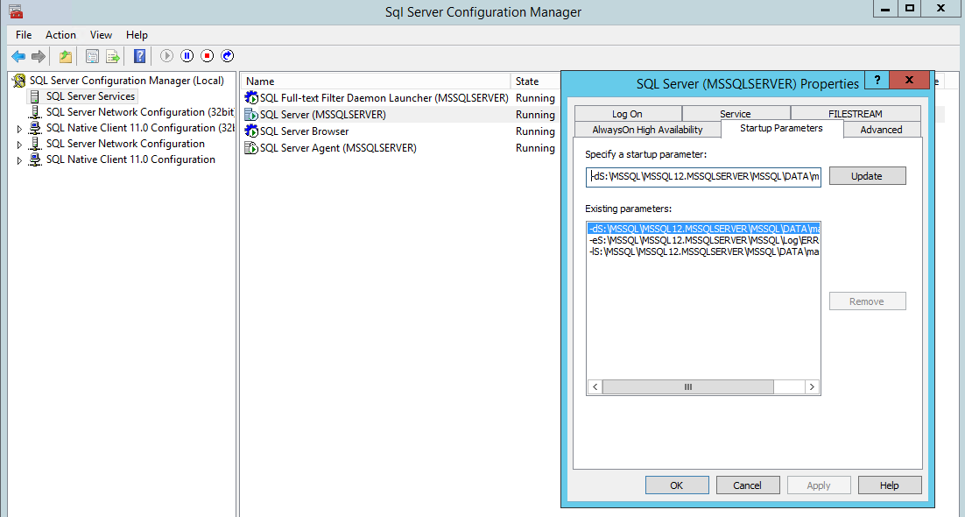

Select the one that you want to change and type the new file location and click in the Update button to save the changes made. Repeat the process for all files that you want to move. When done click on the OK button to return to the SQL Server Services pane.
Stop the respective SQL Server instance service and copy the master database files to the new location. Now when starting the SQL Server instance, the master database files will run from the new location.

MSDB DB and MODEL DB ( Same Process)
TempDB (Since tempdb is recreated every time the SQL Server instance restarts, there is no need to copy the current files to the new location. The only thing that it needs to be done to have these changes implemented is to perform a SQL Server service restart and then the new files will be created in the new location (folder structure should exist). After that, old tempdb data and log files can be deleted from old location.)

-- Moving MSDB Database

USE [master]
GO
SELECT name,
physical_name,
state_desc FROM sys.master_files

/*
C:\Learning\SQL2019\Install\MSSQL15.MSSQLSERVER\MSSQL\DATA\MSDBData.mdf
C:\Learning\SQL2019\Install\MSSQL15.MSSQLSERVER\MSSQL\DATA\MSDBLog.ldf

-- Destination path
C:\Learning\SQL2019\Data\MSDBData.mdf
C:\Learning\SQL2019\Data\MSDBLog.ldf

*/

msdb data and transaction log files can be moved to any other location if and when needed to. Below is a T-SQL code example for moving the default data and transaction log files to a new location

ALTER DATABASE msdb
MODIFY FILE (NAME = MSDBData, FILENAME = 'C:\Learning\SQL2019\Data\MSDBData.mdf');
GO
ALTER DATABASE msdb
MODIFY FILE (NAME = MSDBLog, FILENAME = 'C:\Learning\SQL2019\Data\MSDBLog.ldf');

After running the above command, stop the respective MSSQL instance service and copy the msdb current files to the new location. After the copy finishes successfully, start the respective SQL Server service and verify if there are no issues by checking the database status,

System databases must be rebuilt to fix corruption problems in the master, model, msdb, or resource system databases or to modify the default server-level collation. This topic provides step-by-step instructions to rebuild system databases.
Before You Rebuild the System Databases

When the master, model, msdb, and tempdb system databases are rebuilt, the databases are dropped and re-created in their original location. If a new collation is specified in the rebuild statement, the system databases are created using that collation setting. Any user modifications to these databases are lost. For example, you may have user-defined objects in the master database, scheduled jobs in msdb, or changes to the default database settings in the model database.
Perform the following tasks before you rebuild the system databases to ensure that you can restore the system databases to their current settings.
  - Record all server-wide configuration values.
Copy
SELECT * FROM sys.configurations;
  - Record all service packs and hotfixes applied to the instance of SQL Server and the current collation. You must reapply these updates after rebuilding the system databases.
Copy
SELECT
SERVERPROPERTY('ProductVersion ') AS ProductVersion,
SERVERPROPERTY('ProductLevel') AS ProductLevel,
SERVERPROPERTY('ResourceVersion') AS ResourceVersion,
SERVERPROPERTY('ResourceLastUpdateDateTime') AS ResourceLastUpdateDateTime,
SERVERPROPERTY('Collation') AS Collation;
  - Record the current location of all data and log files for the system databases. Rebuilding the system databases installs all system databases to their original location. If you have moved system database data or log files to a different location, you must move the files again.
Copy
SELECT name, physical_name AS current_file_location
FROM sys.master_files
WHERE database_id IN (DB_ID('master'), DB_ID('model'), DB_ID('msdb'), DB_ID('tempdb'));
  - Locate the current backup of the master, model, and msdb databases.
  - If the instance of SQL Server is configured as a replication Distributor, locate the current backup of the distribution database.
  - Ensure you have appropriate permissions to rebuild the system databases. To perform this operation, you must be a member of the sysadmin fixed server role. For more information, see Server-Level Roles.
  - Verify that copies of the master, model, msdb data and log template files exist on the local server. The default location for the template files is C:\Program Files\Microsoft SQL Server\MSSQL10_50.MSSQLSERVER\MSSQL\Binn\Templates. These files are used during the rebuild process and must be present for Setup to succeed. If they are missing, run the Repair feature of Setup, or manually copy the files from your installation media. To locate the files on the installation media, navigate to the appropriate platform directory (x86, x64, or ia64) and then navigate to setup\sql_engine_core_inst_msi\Pfiles\SqlServr\MSSQL.X\MSSQL\Binn\Templates.
Rebuild System Databases Procedure

The following procedure rebuilds the master, model, msdb, and tempdb system databases. You cannot specify the system databases to be rebuilt. For clustered instances, this procedure must be performed on the active node and the SQL Server resource in the corresponding cluster application group must be taken offline before performing the procedure.
This procedure does not rebuild the resource database. See the section, "Rebuild the resource Database Procedure" later in this topic.
To rebuild system databases for an instance of SQL Server:
  - Insert the SQL Server 2008 R2 installation media into the disk drive.
  - From a command prompt window, enter the following command. Square brackets are used to indicate optional parameters. Do not enter the brackets. When using the Windows Vista operating system with User Account Control (UAC) enabled, running Setup requires elevated privileges. The command prompt must be run as Administrator.
Setup /QUIET /ACTION=REBUILDDATABASE /INSTANCENAME=InstanceName /SQLSYSADMINACCOUNTS=accounts [ /SAPWD= StrongPassword ] [ /SQLCOLLATION=CollationName]
Parameter name | Description
/QUIET or /Q | Specifies that Setup run without any user interface.
/ACTION=REBUILDDATABASE | Specifies that Setup re-create the system databases.
/INSTANCENAME=InstanceName | Is the name of the instance of SQL Server. For the default instance, enter MSSQLSERVER.
/SQLSYSADMINACCOUNTS=accounts | Specifies the Windows groups or individual accounts to add to the sysadmin fixed server role. When specifying more than one account, separate the accounts with a blank space. For example, enter BUILTIN\Administrators MyDomain\MyUser. When you are specifying an account that contains a blank space within the account name, enclose the account in double quotation marks. For example, enter NT AUTHORITY\SYSTEM.
[ /SAPWD=StrongPassword ] | Specifies the password for the SQL Server sa account. This parameter is required if the instance uses Mixed Authentication (SQL Server and Windows Authentication) mode.  Security Note  The sa account is a well-known SQL Server account and it is often targeted by malicious users. It is very important that you use a strong password for the sa login.  Do not specify this parameter for Windows Authentication mode.
[ /SQLCOLLATION=CollationName ] | Specifies a new server-level collation. This parameter is optional. When not specified, the current collation of the server is used.  Important  Changing the server-level collation does not change the collation of existing user databases. All newly created user databases will use the new collation by default.  For more information, see Setting and Changing the Server Collation.
  - When Setup has completed rebuilding the system databases, it returns to the command prompt with no messages. Examine the Summary.txt log file to verify that the process completed successfully. This file is located at C:\Program Files\Microsoft SQL Server\100\Setup Bootstrap\Logs.
Post-Rebuild Tasks

After rebuilding the database you may need to perform the following additional tasks:
  - Restore your most recent full backups of the master, model, and msdb databases. For more information, see Considerations for Backing Up and Restoring System Databases.
Important
If you have changed the server collation, do not restore the system databases. Doing so will replace the new collation with the previous collation setting.
  - If a backup is not available or if the restored backup is not current, re-create any missing entries. For example, re-create all missing entries for your user databases, backup devices, SQL Server logins, end points, and so on. The best way to re-create entries is to run the original scripts that created them.
Security Note
We recommend that you secure your scripts to prevent their being altered by unauthorized by individuals.
  - If the instance of SQL Server is configured as a replication Distributor, you must restore the distribution database. For more information, see Backing Up and Restoring Replicated Databases.
  - Move the system databases to the locations you recorded previously. For more information, see Moving System Databases.
  - Verify the server-wide configuration values match the values you recorded previously.
Rebuild the resource Database Procedure

The following procedure rebuilds the resource system database. When you rebuild the resource database, all service packs and hot fixes are lost, and therefore must be reapplied.
To rebuild the resource system database:
  - Launch the SQL Server Setup program (setup.exe) from SQL Server 2008 R2 distribution media.
  - In the left navigation area, click Maintenance, and then click Repair.
  - Setup support rule and file routines run to ensure that your system has prerequisites installed and that the computer passes Setup validation rules. Click OK or Install to continue.
  - On the Select Instance page, select the instance to repair, and then click Next.
  - The repair rules will run to validate the operation. To continue, click Next.
  - From the Ready to Repair page, click Repair. The Complete page indicates that the operation is finished.
Creating a New msdb Database

If the msdb database is damaged and you do not have a backup of the msdb database, you can create a new msdb by using the instmsdb script.
Caution
Rebuilding the msdb database using the instmsdb script will eliminate all the information stored in msdb such as jobs, alert, operators, maintenance plans, backup history, Policy-Based Management settings, Database Mail, Performance Data Warehouse, etc.
  - Stop all services connecting to the Database Engine, including SQL Server Agent, SSRS, SSIS, and all applications using SQL Server as data store.
  - Start SQL Server from the command line using the command: NET START MSSQLSERVER /T3608
For more information, see How to: Start an Instance of SQL Server (net Commands).
  - In another command line window, detach the msdb database by executing the following command, replacing <servername> with the instance of SQL Server: SQLCMD -E -S<servername> -dmaster -Q"EXEC sp_detach_db msdb"
  - Using the Windows Explorer, rename the msdb database files. By default these are in the DATA sub-folder for the SQL Server instance.
  - Using SQL Server Configuration Manager, stop and restart the Database Engine service normally.
  - In a command line window, connect to SQL Server and execute the command: SQLCMD -E -S<servername> -i"C:\Program Files\Microsoft SQL Server\MSSQL10_50.MSSQLSERVER\MSSQL\Install\instmsdb.sql" -o" C:\Program Files\Microsoft SQL Server\MSSQL10_50.MSSQLSERVER\MSSQL\Install\instmsdb.out"
Replace <servername> with the instance of the Database Engine. Use the file system path of the instance of SQL Server.
  - Using the Windows Notepad, open the instmsdb.out file and check the output for any errors.
  - Re-apply any service packs or hotfix installed on the instance.
  - Recreate the user content stored in the msdb database, such as jobs, alert, etc.
  - Backup the msdb database.
Troubleshooting Rebuild Errors

Syntax and other run-time errors are displayed in the command prompt window. Examine the Setup statement for the following syntax errors:
  - Missing slash mark (/) in front of each parameter name.
  - Missing equal sign (=) between the parameter name and the parameter value.
  - Presence of blank spaces between the parameter name and the equal sign.
  - Presence of commas (,) or other characters that are not specified in the syntax.
After the rebuild operation is complete, examine the SQL Server logs for any errors. The default log location is C:\Program Files\Microsoft SQL Server\100\Setup Bootstrap\Logs. To locate the log file that contains the results of the rebuild process, change directories to the Logs folder from a command prompt, and then run findstr /s RebuildDatabase summary*.*. This search will point you to any log files that contain the results of rebuilding system databases. Open the log files and examine them for relevant error messages.

